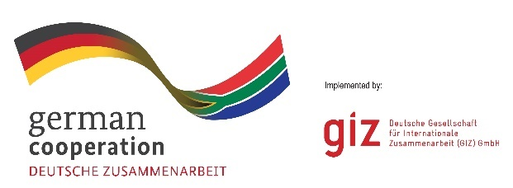

**CALL FOR PROPOSALS: 83484477**

**Battery Subject Matter Expert to support the creation of documents for the EU and the inception phase of a project.**

The Deutsche Gesellschaft für Internationale Zusammenarbeit (GIZ) GmbH is an international cooperation partner, implementing sustainable development projects on behalf of the German Federal Government. GIZ’s corporate objective is to improve people’s living conditions on a sustainable basis. Since 2021, GIZ is implementing the project “Promoting a South African Green Hydrogen Economy” (H2.SA), on behalf of The German Federal Ministry for Economic Cooperation and Development (BMZ).

South Africa has everything necessary to position itself internationally as a producer of green hydrogen and derived products, including exceptional potential for wind and solar energy as well as available land, and a supportive policy framework. In addition to the possibility for export, there is also considerable potential for the domestic use of green hydrogen to reduce the use of fossil fuels in industry. Since 2021, German technical cooperation (TC) has been supporting South Africa in the development of a green hydrogen economy through the TC module "Promoting the development of a hydrogen economy for South Africa" (H2.SA). The follow-up phase of the H2.SA project phase was decided at the bilateral government consultations in February 2024.

As part of a combined financing from the European Union (EU), the technical cooperation in the field of green hydrogen will be scaled up and the additional topic battery value chains for electromobility and electricity storage will be added. In the area of battery value creation, the focus will be on the local processing of minerals and the production of batteries. In March, an appraisal mission will take place, which consists of stakeholder interviews to get a better understanding of needs, challenges, and opportunities for the creation of battery value chains in South Africa and identifying key stakeholders and potential project partners. The mission will be carried out by a mission team consisting of GIZ personnel and external experts. After the mission, a full proposal must be developed consisting of project documents for the German commissioning agency as well as for the EU delegation to South Africa. GIZ is looking for a technical expert to provide input to the development of the “Document of Action” (DoA), which is the core document for the project proposal towards the EU. Also, the expert shall provide technical backstopping during the project's preparation and inception phase.

GIZ invites eligible and professional expert in South Africa to participate in this tender.

**Queries** must be made in writing only, reaching GIZ not later than **21.03.2025**, and addressed **strictly and only** to: [**procurement.pretoria@giz.de**](mailto:procurement.pretoria@giz.de)

**Proposal** must be **submitted only to** **ZA_Quotation@giz.de by 30 March 2025. Please quote reference 83484477** when submitting the documentation. **Late submissions will not be accepted.**