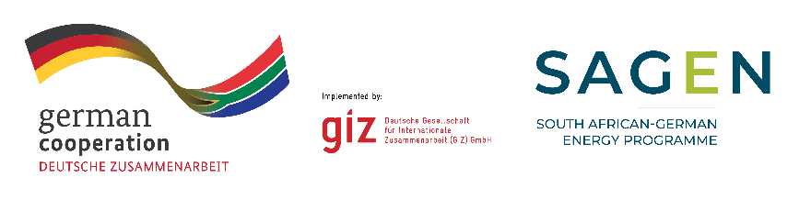

**Call for Proposals: 83482051**

**Assessing the Feasibility of Microgrids for the Electrification of Urban Informal Settlements in South Africa**

The South African-German Energy Programme (SAGEN) supports South African partners to manage the energy transition with a focus on renewable energy and energy efficiency. SAGEN is funded by the German Federal Ministry for Economic Cooperation and Development (BMZ) and implemented by the Deutsche Gesellschaft für Internationale Zusammenarbeit (GIZ) in cooperation with the Department of Mineral Resources and Energy (DMRE), Eskom and the South African Local Government Association (SALGA) under the government-to-government coordination of National Treasury (NT).

As part of the collaboration with SALGA and municipalities, SAGEN would like to explore the feasibility of clean solutions such as micro/mini grids for the electrification of urban informal settlements as part of the transition towards a more inclusive, decentralised, and sustainable energy system. Consultants are required to develop a tool in order to assess and prioritise locations for microgrid projects and support aspects of the design thereof. In addition, consultants are required to undertake a pre-feasibility study for a microgrid system in an urban informal settlement in the City of Cape Town looking at the technical, financial, social and governance aspects of the project.

GIZ invites eligible and professional companies with local presence in South Africa to participate in this tender.

Queries must be made in writing only, reaching GIZ not later than **14.03.2025**, and addressed **strictly and only** to: [**procurement.pretoria@giz.de**](mailto:procurement.pretoria@giz.de)

Your proposal must be **submitted only to** **ZA_Quotation@giz.de by 23 March 2025. Please quote reference 83482051** when submitting the documentation. **Late submissions will not be accepted.**