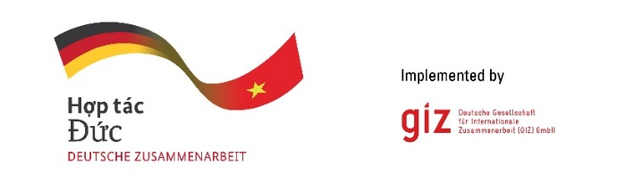

Calling for expression of interest
Conduct market assessment study for revising the national technical standard
of the room air conditionings in Vietnam
Tender code: 83485453

- Background
As a federally owned enterprise, the Deutsche Gesellschaft für Internationale Zusammenarbeit (GIZ) GmbH supports the German Government in achieving its objectives in the field of international cooperation for sustainable development. On behalf of the German Government, GIZ provides advisory services to the Vietnamese Government in four priority areas: (1) Vocational training, (2) Environmental, (3) Energy, and (4) Sustainable Economic Development. For further information, please visit www.giz.de/viet-nam.

Acceleration of Air Conditioning Transformation through Enhanced Energy Performance Standard (ACT MEPS) is a regional project which is funded by a sustainable cooperation and cooling progamme (Clean Cooling Collaborative), an initiative of the ClimateWorks Foundation, a non-profit organization, focuses geographically on Vietnam and the Philippines. The scope for Vietnam portion includes the revision of TCVN 7830:2021 to assess and increase the MEPS and energy efficiency levels of the Room Air conditioning (RAC). In this line, the ACT MEPS project plans to conduct the market assessment for revising the national technical standard for room air conditionings in Vietnam.

The GIZ Office Hanoi as the contracting party, on behalf of the ACT-MEPS project, is conducting a local negotiated tender to look for qualified Local Consulting Firm (LCF) to implement the assignment.
Tentative duration: from 15 June 2025 until 30 January 2026
Place of assignment: in Vietnam
Estimate working days: up to 200 working days for an expert team of 3 members

- Requirements for the LCF
- Commercial register entry
- Average annual turnover for the last three financial years
At least: 80.000 EUR
- Average number of employees and managers for the past three calendar years
At least: 5 persons
- Technical experience assessment is based on reference projects that were conducted by LCF with a minimum value of 15.000 EUR to satisfy the folowing:
at least 1 reference project in the technical field about market assessment in cooling sector;
at least 1 reference project cooling sector in Viet Nam in the last 5 years (period March 2020-March 2025);
at least 10 years of working experience in the energy, environment or cooling sector;
and having experience of 1 development project (at least 50% ODA-financed).

- Requirements for eligibility documents
Interested LCFs are requested to prepare the following documents in English:
- Letter of interest (with Director’s or authorised person’s signature and company stamp).
- Audited financial reports of the last 03 years. Important/key information in the audited financial reports or in annual tax reports must be translated into English if documents are in Vietnamese.

- LCF profile and technical experience, incl. Business license (for firm) or Decision of establishment (for association); Tax code registration; organisational chart; consortium agreement and nomination of consortium leading firm (if at least 02 entities join the assignment); similar experience/copy of contracts related to this assignment.

- Method of bid submission
LCFs send Eligibility dossiers to VN_PoS_Quotation@giz.de before 5 PM (Hanoi time) on 24.04.2025 with email subject: “Tender 83485453-Eligibility dossier-Company name”.

For data protection and information security reason: In case the total volume of your bids is below 10 MB, you can attach them directly in the email sent to us. In case the total volume of your bids is above 10 MB, the files must be sent via GIZ filetransfer system. We will provide guidance for using our filetransfer. Links stated in documents and files sent via other applications/systems are not accepted.

Bids sent after the submission deadline and bids sent to wrong email address will be disqualified.

- Notes
- Request of tender documents to be sent to Question-from-bidder-PoS-VN@giz.de before 10.04.2025.
- Eligibility assessment related questions to be sent to Question-from-bidder-PoS-VN@giz.de before 17.04.2025.
- Only selected bidders will be invited to present technical and financial offers.
- For the exchange rate at the corresponding time, please go to https://commission.europa.eu/funding-tenders/procedures-guidelines-tenders/information-contractors-and-beneficiaries/exchange-rate-inforeuro_en

GIZ is obliged to ensure the confidentiality of all submitted documents by bidders.

