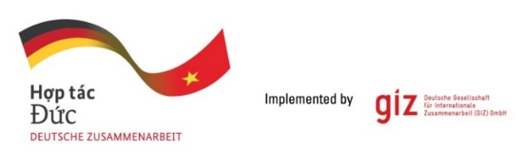

**Calling for expression of interest (EOI)**

**Tender package: 83479328**

**Assignment: Piloting and assessing innovative climate risk finance for rice in the Mekong River Delta**

As a federal enterprise, the **Deutsche Gesellschaft für Internationale Zusammenarbeit (GIZ) GmbH** supports the German Government in achieving its objectives in the field of international cooperation for sustainable development. On behalf of the German Government, GIZ currently provides advisory services to the Government of Viet Nam in three priority areas: Vocational training, Environmental policy and sustainable use of natural resources, and Energy. For further information, please visit [www.giz.de/viet-nam](http://www.giz.de/viet-nam).

The project Innovative climate risk finance for the agriculture sector in the ASEAN region (AgriCRF) under the GIZ is looking for a local company which could run pilots and assessment of innovative climate risk finance for rice in 4 selected provinces in the Mekong River Delta (An Giang, Dong Thap, Kien Giang, Soc Trang). While the assignment request the Contractor can work with different insurance companies to design the pilot, **an insurance company is not eligible to apply for this assignment.** The company should include an expert team for the positions: **01 Team Leader and 02 members** to conduct the assignmentwith the tentative timeframe of the assignment: Starting March 2025 to December 30th, 2025.

Request for Eol assessment grid with detailed assessment criteria and weighting might be sent in writing via email to **[Question-from-bidder-PoS-VN@giz.de](mailto:Question-from-bidder-PoS-VN@giz.de)** by **18.12.2024.**

Interested service providers should send an expression of interest (Eol) documents in English containing:

1. Letter of interest (with director’s signature and company stamp) (A/I/2 EoI Assessment)
2. Copy of audited financial report and/or annual tax report accepted by tax authorities of last 02 years (2022-2023) and up to date financial report in 2024 (could be in Vietnamese, incl. balance sheet, income statement, cashflow statement, tax liquidation) in which the annual turnover for the financial year 2022 is more than 100,000 Euro and average annual turnover for the last two financial years (2023 & up-to-date 2024) is more than 150,000 Euro. (A/I/4.1 + 4.2 EoI Assessment)
3. Company profile (incl. copy of business license, tax code registration, organization chart, personnel structure in which average number of employees and managers for 2022-2023-2024 is more than 5 persons) and the proven record of company working experience for our assessment. (A/I/3 + 5 + B EoI Assessment)

The bidders send Eligibility dossiers to **[VN_PoS_Quotation@giz.de](mailto:VN_PoS_Quotation@giz.de)** latest by 17:00 (Hanoi time) on **20.12.2024** with email subject: “**Tender 83479328-EOI-Climate risk finance for rice**”.

GIZ is obliged to ensure the confidentiality of all bidding documents submitted.

**Important notes:**

1. Request of tender documents to be sent to [Question-from-bidder-PoS-VN@giz.de](mailto:Question-from-bidder-PoS-VN@giz.de) by 18.12.2024
2. Eligibility assessment related questions to be sent to [Question-from-bidder-PoS-VN@giz.de](mailto:Question-from-bidder-PoS-VN@giz.de) by 20.12.2024
3. Eligibility dossier to be sent to [VN_PoS_Quotation@giz.de](mailto:VN_PoS_Quotation@giz.de) by 17:00 on 20.12.2024. Sending documents to wrong email address will lead to disqualification of the bidder.
4. Only selected bidders will be invited to present technical and financial offers.
5. This is negotiated tender with competitive tendering

**Note: all bidders must meet all requirements in Part A of Eol assessment grid to be eligible for Part B assessment. Minimum points for Part B is 500/1000 points.**