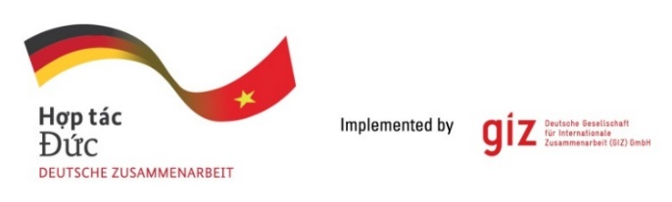**Calling for expression of interest (EoI)**

As a federally owned enterprise, Deutsche Gesellschaft für Internationale Zusammenarbeit (GIZ) GmbH supports the German Government in achieving its objectives in the field of international cooperation for sustainable development. On behalf of the German Government, GIZ provides advisory services to the Vietnamese Government in four priority areas: (1) Vocational training, (2) Environmental, (3) Energy, and (4) Sustainable Economic Development. For further information, please visit [www.giz.de/viet-nam](http://www.giz.de/viet-nam).

Due to a high number of national personnel working for the GIZ Vietnam (300-350 Vietnamese staff working countrywide in Vietnam, 1000-1200 consultants/year) and for seeking for the more professionalism in payroll administration, the GIZ Hanoi Office is conducting a local public tender to seek for an eligible and experienced service provider to offer the best value for money service in Payroll Administration to GIZ Vietnam for up to 3 year from Jan 2025 to December 2027.

Request for Eol assessment grid with detailed assessment criteria and weighting might be sent in writing via email to [**Question-from-bidder-PoS-VN@giz.de**](mailto:Question-from-bidder-PoS-VN@giz.de)by **13.10.2024.**

Interested service providers should send an expression of interest (Eol) documents in English containing:

1. Letter of interest (with director’s signature and company stamp)
2. Company profile (incl. business license, tax code registration, organization chart, personnel structure, service catalogue, registration paper of main offices in Hanoi, decision on appointment of department and personnel in charge of personal data protection Pursuant to the Decree No. 13/2023/ND-CP dated 17 April 2023 on protection of personal data (“Decree 13”) – (A&B-Eol Grid)
3. Copy of audited financial report of 2021-2023 (incl. balance sheet, income statement, cash flow statement, tax liquidation) and/or annual tax report accepted by tax authorities. (A/I/1.3 & B/III/2 EoI assessment)
4. 3 reference letters with concrete contract information (name/institution/ email address/ telephone number) (A/II/ EoI assessment)
5. Proof of 10 years relevant experiences in payroll administration services to comparable companies like GIZ Vietnam (Client list, duration of contracts, kind & size of clients and services provided, quantity & volume of contracts, having relevant experience in providing payroll services to international organizations like GIZ would be an advantage) (B/III/3 EoI assessment)

Data security and data protection management system shall be checked by GIZ.

The bidders send Eligibility dossiers to [**VN_PoS_Quotation@giz.de**](mailto:VN_PoS_Quotation@giz.de) latest by 17:00 (Hanoi time) on **17.10.2024** with email subject: “**Tender 83472069-EOI-Payroll Administration**”.

GIZ is obliged to ensure the confidentiality of all bidding documents submitted.

**Important notes:**

1. Request of tender documents to be sent to [Question-from-bidder-PoS-VN@giz.de](mailto:Question-from-bidder-PoS-VN@giz.de) by dd.mm.yy
2. Eligibility assessment related questions to be sent to [Question-from-bidder-PoS-VN@giz.de](mailto:Question-from-bidder-PoS-VN@giz.de) by dd.mm.yy
3. Eligibility dossier to be sent to [VN_PoS_Quotation@giz.de](mailto:VN_PoS_Quotation@giz.de) by 17:00 on 17.10.2024. Sending documents to wrong email address will lead to disqualification of the bidder.
4. Only selected bidders will be invited to present technical and financial offers.
5. This is negotiated tender with competitive tendering

Note: all bidders must meet all requirements in Part A to be eligible for Part B assessment. Minimum points for Part B is 500/1000 points.