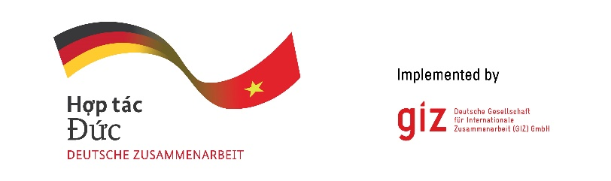

Calling for expression of interest
Solutions to attract investment in power projects through adjusting financial discount coefficient (depreciation) to promote
Tender code: 83482646

- Background
As a federally owned enterprise, the Deutsche Gesellschaft für Internationale Zusammenarbeit (GIZ) GmbH supports the German Government in achieving its objectives in the field of international cooperation for sustainable development. On behalf of the German Government, GIZ provides advisory services to the Vietnamese Government in four priority areas: (1) Vocational training, (2) Environmental, (3) Energy, and (4) Sustainable Economic Development. For further information, please visit www.giz.de/viet-nam.

The project “Promoting the transition of the energy sector in Viet Nam” (TEV) funded by German Federal Ministry for Economic Cooperation and Development (BMZ), to foster the development of a long-term political energy transition strategy, including legal and regulatory fundamentals, as well as the transfer of technological knowledge to MOIT (i.e., ERAV and EREA).

The GIZ Office Hanoi as the contracting party, on behalf of the TEV project, is conducting a local negotiated tender to look for qualified Local Consulting Firm (LCF) to Study current regulations and international experience to propose methods to adjust financial discount coefficient and depreciation duration of fixed assets in accordance with the "Lifespan/Economic Life of Assets" to help regulate the financial mechanism of power source and grid projects within the allowable scope to ensure the ability to recover investment capital and reasonable profits for investors while still ensuring the affordability of end-users of electricity in the context of strong energy transition in Vietnam towards the goal of Net Zero 2050.
- Tentative duration: from 25 April 2025 until 30 September 2025
- Place of assignment: Vietnam
- LCF’s number of estimate working days: up to 99 for an expert team of 3 members
- Requirements for the LCF:
- Compliance with legal requirements (e.g. commercial and tax registration, relevant licences etc)
- Technical experience in Power development planning, Power investment mechanism, Electricity pricing (with at least 03 reference projects) among which at least 1 reference project in Vietnam in the last 3 years.
- Experience in working with MOIT (ERAV or EREA)

- Requirements for eligibility documents
Interested LCFs are requested to prepare the following documents in English :
- Letter of interest (with Director’s or authorised person’s signature and company stamp).
- LCF profile (incl. Business license (for firm) or Decision of establishment (for association), Tax code registration, organisational chart, similar experience/copy of contracts related to this assignment).
- Audited financial reports of the last 03 years. Important/key information in the audited financial reports or in annual tax reports must be translated into English if documents are in Vietnamese.
- Consortium agreement and nomination of consortium leading firm (if at least 02 entities joint the assignment).

- Method of bid submission
LCFs send Eligibility dossiers to VN_PoS_Quotation@giz.de latest by 17:00 (Hanoi time) on 09.03.2025 with email subject: “Tender 83482646-Eligibility dossier-Company name”.
Bids sent after the submission deadline will be disqualified.

- Notes
- Request of tender documents to be sent to Question-from-bidder-PoS-VN@giz.de before 21.02.2025.
- Eligibility assessment related questions to be sent to Question-from-bidder-PoS-VN@giz.de before 02.03.2025.
- Sending documents to wrong email address will lead to disqualification of the supplier.
- Only selected bidders will be invited to present technical and financial offers.

GIZ is obliged to ensure the confidentiality of all submitted documents by bidder(s) during tender process.

